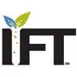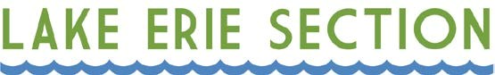

INSTITUTE OF FOOD TECHNOLOGISTS LAKE ERIE SECTION
SCHOLARSHIP RULES FOR ACADEMIC YEAR 2026

- Scholarship applicants will be eligible to win anywhere from $1,000 up to $2,500.

- The scholarship recipient must be a student or a graduate student majoring in Food Science, Human Nutrition, or related fields with the intent to work within the food industry. Additionally, an undergraduate must have completed a minimum of three quarters or two semesters in the aforementioned degrees.

- Each recipient must have a permanent, legal residence within the region defined by the following counties: Ashtabula, Ashland, Carroll, Columbiana, Cuyahoga, Erie, Geauga, Harrison, Holmes, Huron, Jefferson, Lake, Lorain, Mahoning, Medina, Portage, Richland, Stark, Summit, Trumbull, Tuscarawas and Wayne.

- A single recipient may receive a scholarship more than one year but must re-apply yearly.

- Scholarship recipients are selected by the Lake Erie IFT Scholarship Committee.

- Each applicant is required to submit:

- A completed scholarship application
- Official transcripts or unofficial electronic transcripts from current university
- One signed academic or professional letter of reference. Please have reference send recommendations directly to Sara Rouse (sara.rouse@us.nestle.com) and Megan Fox (megan.fox@jmsmucker.com)

- All applications must be submitted by April 5, 2026. Applications received after this date will not be considered.

- Recipients are required to attend the LEIFT Suppliers Expo on May 20, 2026 to receive their scholarship money.

- The completed application with transcript(s), recommendation letter, or any questions should be submitted directly to Sara Rouse (sara.rouse@us.nestle.com) and Megan Fox (megan.fox@jmsmucker.com)

